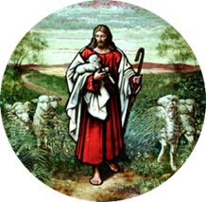
St. John’s Evangelical Lutheran
Church and School (LCMS)
9141 County Road 101
Corcoran, MN 55340
763-420-2426 or FAX 763-420-7198

Matthew V. Moss, Pastor
Matthew P. Johnson, Pastor
Gary Volberding, Principal
Suzanne Haag, Admissions & Communication Director

“Learning and Living as God’s Baptized Children”

BAPTISM APPLICATION

DATE:__________________________

CHILD’S FULL NAME:__________________________________________________________________

BIRTHDATE:__________________________________________________________________________

BIRTHPLACE: (City,State,Hospital)________________________________________________________

FATHER’S FULL NAME:________________________________________________________________

CHURCH MEMBERSHIP:________________________________________________________________

MOTHER’S FULL NAME:_______________________________________________________________

CHURCH MEMBERSHIP:_______________________________________________________________

FAMILY ADDRESS:____________________________________________________________________

CITY/STATE/ZIP:______________________________________________________________________

PHONE:_______________________________________________________________________________

EMAIL: _______________________________________________________________________________

LCMS SPONSORS: (Must be LCMS Members)_______________________________________________

WITNESSES: (optional)__________________________________________________________________

PUBLIC SERVICE?________________________PRIVATE SERVICE?___________________________

DATE/TIME OF BAPTISM SERVICE:______________________________________________________

OFFICIANT:___________________________________________________________________________

